Sir John A. Macdonald Secondary School English and Drama Department

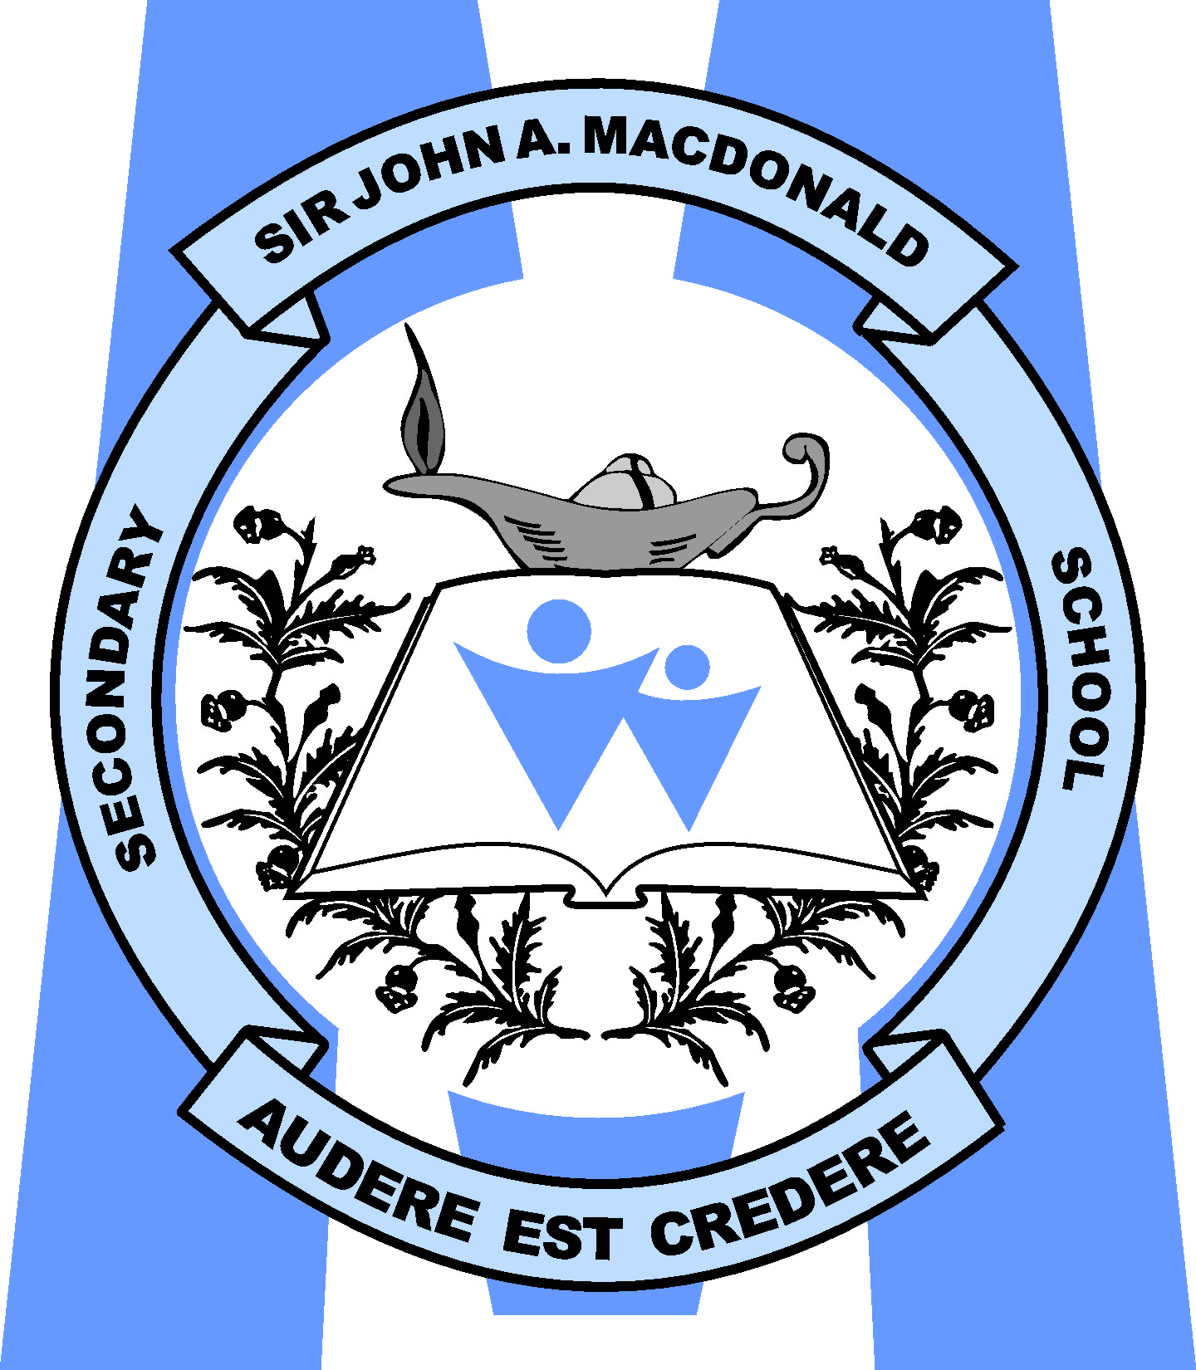
Grade 11 Drama

Course Description
This course provides opportunities for students to explore dramatic forms, conventions, and techniques. Students will explore a variety of dramatic sources from a various cultures and representing a range of genres. Students will use the elements of drama in creating and communicating through dramatic works. Students will assume responsibility for decisions made in the creative and collaborative processes and will reflect their experiences.

Identifying Information
Course Title: | Grade 11 Drama
Course Code: | ADA 3MI
Course Type: | University/College
Grade: | 11
Credit Value: | 1
Ministry Document: | The Ontario Curriculum, Grades 11 and 12: The Arts, 2010, Revised  www.edu.gov.on.ca/eng/curriculum/secondary/arts1112curr2010.pdf
Textbook: | Drama Basics

Course Units
Unit | Description - Weight (70%)
1 | Ensemble Creation  - Students will create radio dramas incorporating the elements of ensemble and vocal techniques
2 | Dramatic Movement  - Research unit combining major theorists of movement and stage with principles and original creation.
3 | Beyond the Self Monologues  - Monologue development techniques demonstrated through varied sources. Students will create an original character and develop a monologue performance in character.
4 | Modern Theatre  - Historical and cultural and political theatre movements combine in seminar and scene study performance. Independent study will comprise part of this unit. Students will study a full book play The Laramie Project and perform scene studies during this unit.
5 | Shaping Themes into a Theatrical Style  - Based on units 2 and 4, groups create an original production in a theatrical style studied.
6 | Performance Criticism  - Utilizing theatre appreciation and criticism to review two live performances.
Drama in the Community - Summative Project Performance/Portfolio (30%)
- Production Unit: Students will join a theatre company to mount a production evening. All aspects of the technical, performance and production roles will be shared and students expected to be in attendance for the evening as well as any additional rehearsals scheduled in advance.
- Written assignments include work/role diary, rehearsal best practices, final reflection

Essential Course Components
To be successful in this course you must be able to demonstrate all of the following skills.
- A1. The Creative Process: use the creative process and a variety of sources and forms, both individually and collaboratively, to design and develop drama works;
- A2. Elements and Conventions: use the elements and conventions of drama effectively in creating
individual and ensemble drama works, including works based on a variety of sources;
- A3. Presentation Techniques and Technologies: use a variety of presentation techniques and technological tools to enhance the impact of drama works and communicate for specific audiences and purposes.
- A3.2 use different acting approaches to explore and depict character in a variety of situations
- B1. The Critical Analysis Process: use the critical analysis process to reflect on and evaluate their own and others’ drama works and activities;
- B2. Drama and Society: demonstrate an understanding of how societies present and past use or have used drama, and of how creating and viewing drama can benefit individuals, groups, and communities;
- B2.1 identify different purposes for drama and the forms used to achieve these purposes in diverse communities and cultures from the
- past and present
- B3. Connections Beyond the Classroom: identify knowledge and skills they have acquired through drama activities and ways in which they can apply this learning in personal, social, and career contexts.
- C1. Concepts and Terminology: demonstrate an understanding of the nature and functions of drama forms, elements, conventions, and techniques, including the correct terminology for the various components;
- C2. Contexts and Influences: demonstrate an understanding of the origins and development of drama and theatre arts and their influence on past and present societies;
- C2.1 demonstrate an understanding of the theatre traditions of a variety of historical periods and cultures
- C3. Responsible Practices: demonstrate an understanding of safe, ethical, and responsible personal and interpersonal practices in drama activities.

Teacher Contact Information
The teacher for this course is Melissa Roe
She can be reached at (519) 880 – 9979 x 5060 or melissa_roe@wrdsb.on.ca
Our class website is: roeyourboat.weebly.com > ADA 3MI

Procedures
Key values of Sir John A. Macdonald Secondary School and the WRDSB include respect, responsibility, honesty, and trustworthiness. Our expectations for student behaviour and academic conduct come from these core values. In accordance with Waterloo Region District School Board guidelines outlined in the Assessment, Evaluation, and Reporting Handbook, the following policies are in effect at SJAM:
- Late and Missed Assignments
Completing tasks on time has been shown to be a key part of school success. It is the expectation that students will submit all required work by the assigned deadlines.
- If work is not submitted on time, next steps will involve student-teacher conferences, parent/guardian contact and may include student referral to in-school supports.
- The teacher will determine a date after which he/she will no longer accept an assignment for marks. In the absence of these student products, teachers will use professional judgement to determine a grade based on evidence of learning available/seen to that point.
- If one or more assignments are not completed, students risk losing the credit for the course.
- The Learning Skills section of the student’s Provincial Report Card will be used to reflect incidents of late and missed assignments.

- Cheating and Plagiarism
It is the expectation that students will submit their own, original work for the purpose of demonstrating their learning. Note that plagiarism includes both sharing original work and using work that is not one’s own. In the event that cheating or plagiarism occurs, the following consequences may be implemented, in consultation with administration, depending on the situation:
- The student who plagiarizes will be required to complete the SJAM Academic Honesty Remediation Tutorial.
- The student may be required to redo all or part of the assignment or assessment.
- The student may be required to complete an alternate assignment or assessment.
- Consequences may include a loss of access to academic awards and scholarship opportunities.
- Plagiarism will be reflected in the Learning Skills section of the student’s Provincial Report Card.
- Potential disciplinary actions may also include suspension.

- Waterloo Region District School Board Policy for Provincial Report Card marks below 50%
For grades 11 and 12:
If a student does not earn the credit for the course, the student’s mark will be reported as follows:
- a mark in the range of 35-45% only.
Or
- a mark of 0 will be assigned if a student has demonstrated NO evidence of achievement.

For grades 9 and 10:
If a student does not earn the credit for the course, the student’s mark will be reported as follows:
- a mark of 45%.
Or
- an "I" for insufficient evidence.

Agreement
Please print your name and sign below indicating you have read and understand the requirements for successful completion of this course.
Student Name |  | Parent/Guardian Name
Student Signature |  | Parent/Guardian Signature
Date |  | Date
Preferred Method of Contact |  | Daytime phone number
- Phone
- Email |  | Email (Please provide if possible)

